Story on George Anthony Voyage, OAM.
Long-time Greek amateur footy and cricket stalwart joins Australia’s honours list

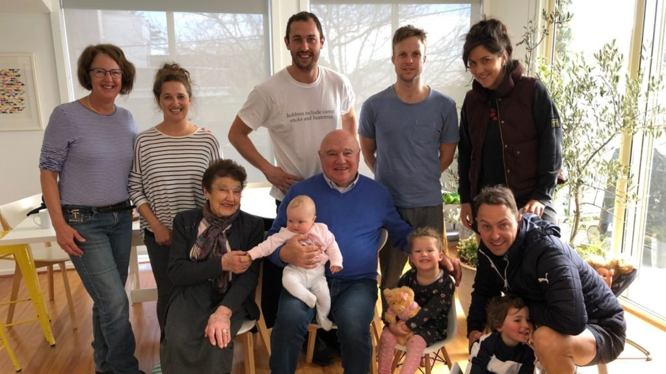
Proud Voyage family: (back row, from left) Jenny (George Voyage’s wife) Katherine (daughter) Nick (son) Tom (husband of Katherine) Louise (wife of Anthony). Front row seated from left: Katina (mother), George Voyage OAM, Evie and Isabella (Katherine’s daughters), and son Anthony with his son Oscar. Photo: Supplied
Story by Alex Economou
9 February 2021 12:00pm Published in Neos Kosmos - Reproduced here with permission, or if you prefer go to the following link which should be operational for a while. https://neoskosmos.com/en/184991/long-time-greek-amateur-footy-and-cricket-stalwart-joins-australias-honours-list/
With 74 clubs in Melbourne with 14,000 male and 4,000 female players, the Victoria Amateur Football Association (VAFA) is the largest Australian Rules competition in Australia. George Voyage (or Voyatzis) OAM has been its president of VAFA since 2018 and he has served the association as a volunteer for most of his life.
He has also been a long-serving volunteer at two famous Melbourne cricket clubs, Brighton and St Kilda’s and last week he was awarded the Medal of the Order of Australia for services to “Australian Rules Football and to cricket Australia”.
His deep and long-term involvement in these sports does not preclude him from a love of soccer where he is a member of Melbourne Victory and as a child would go on Sundays with his father and uncles to watch South Melbourne Hellas in action.
“I played in the VAFA as a player and then served as the state coach (1997 to 2007) and I then moved on to the VAFA board. I have had a 50-year association with VAFA.
“It is fiercely competitive and we rely on our traditions (the VAFA was founded in 1892) and the core values which are fair play and respect for all. It is a very strong competition, but everyone socializes after a game,” said Mr Voyage.
The family’s association with Australian Rules Football goes back a long way. His uncles were Peter and Kon Kanis who starred in the Hawthorn sides of the 1950s. Hawthorn celebrated its first premiership in 1961 at Kon Kanis’ restaurant.
His cousin. John Kanis, (the son of Kon) was a star amateur player and an All-Australian amateur.
He recalled that in the 1970s there was a Greek team in the VAFA, the Kassies (from Castellorizo community, the island from which his family hails) and in the 1950s and 60s the Olympic foot team played on Sundays in Melbourne.
Mr Voyage, a second-generation Australian, was born in 1952 and grew up in Brighton with his younger siblings, John and Maria. His father, Anthony, had come to from Castellorizo after the Second World War. His mother’s family had arrived in Melbourne a generation earlier, in 1919.
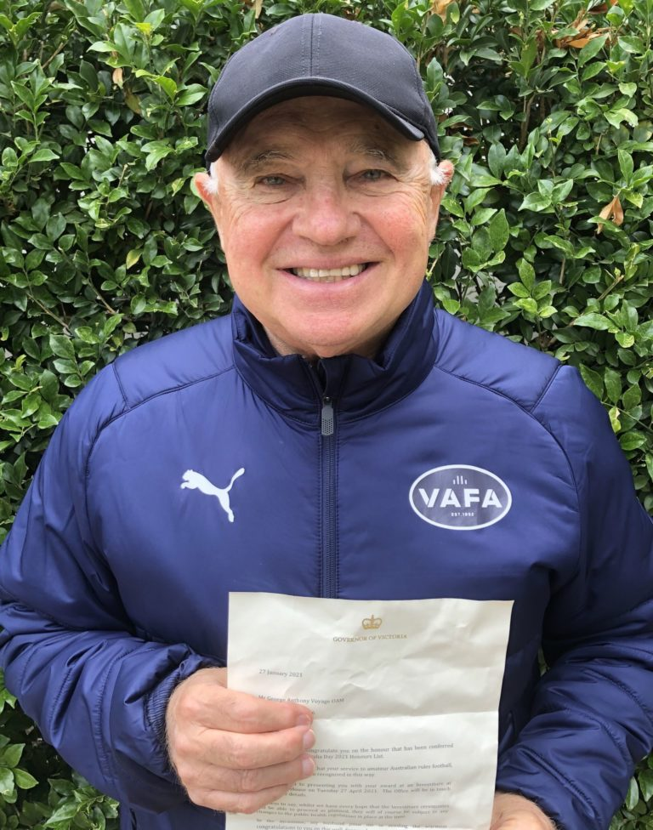
George Voyage holds out the citation the Medal of the Order of Australia for his services to Australian Rules Football and to cricket Australia. Photo: Supplied
He went to Caulfield Grammar and graduated with a business and accounting degree from RMIT.
In the 1950s, his father had founded AG Voyage Australia Ltd which was the first company in Australia to trade mainly in textiles with mainland China. On graduating from RMIT, Mr Voyage joined his father’s company while playing his footy and cricket in his spare time.
“My dad was not happy when I would come to work with bandaged and sporting a black eye. He did not think it looked good when dealing with important retail clients. But it helped especially when the customer would also come to a meeting sporting a black eye from a weekend game.”
“I first went to China in 1972 before Gough Whitlam or President Richard Nixon. I loved it the people were wonderful, very engaging and hospitable. I would go for a walk and would have about 200 people following me trying their English on me,” he reminisced.
“We pioneered a lot of supermarket items from China in Australia. My father was often quoted in the Australia media about China. I remember when my father appeared on Four Corners and said that one day China would make its own cars and aircraft to sell to the world and he was ridiculed for it in the media the next day,” said Mr Voyage.
At first, he said, the company could only trade through designated national trading companies.
“We had to buy from 10 designated corporations but the factories in the cities soon began to compete with each other for business.
“We have tried to maintain our relations with people we used to do business with before. In the old days you would get one price (for a product) and that was it. Now you haggle on prices, quality and workmanship. China’s products have improved over the years,” he said.
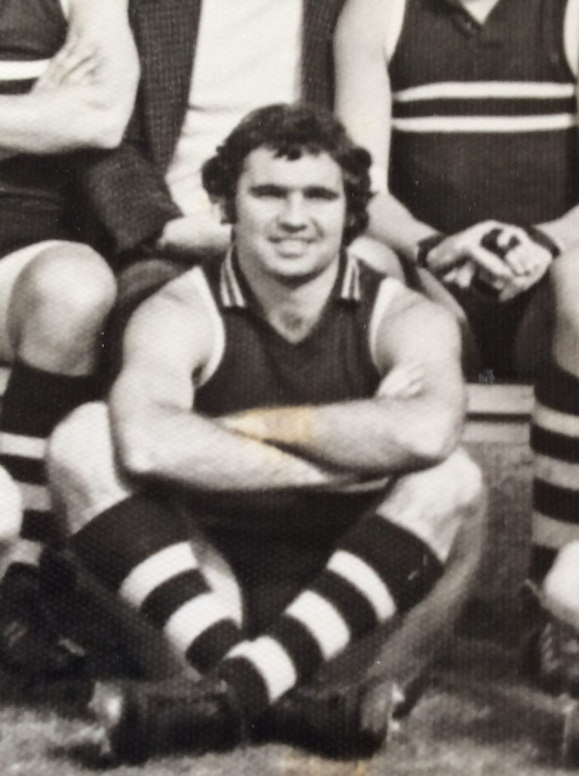
George Voyage in his amateur footy playing days. Photo: Supplied
Mr Voyage apologises for the Greek that he speaks but it is good enough for a conversation and his love of the country is deep.
“I have been to Greece at least 20 times over the years and I like to go there regularly.
“I am defined by the values installed by my parents: Selflessness, a hard work ethic, respect for others. Team sports bring these values to the forefront,” he added.
Mr Voyage is married to Jenny, an Australian of Swedish and German descent. He has three children Katherine and Anthony who are twins and the youngest is Nicholas.
He said his award was a recognition of the contribution of people with a Greek background to Australian society and was particularly glowing of his praise for Eleni Gloufitsis who was recognised for her pioneering role as the first woman field umpire in the Australian Football League, the professional league of the sport.
“It is great for Eleni to reach this level, it is a great achievement.”

