In 2011 I began duties as KAV Archivist, following in the footsteps of Marie and Nick Zorbas and Peter Augustes. Professional historians have since informed me that the job title is actually a misnomer. It should be titled Curator which also encompasses clothing, textiles and artefacts. (An Archivist would normally just work with digital and hard-copy records, documents, photographs etc).

Shortly after I was appointed I was fortunate enough to attend a conference in Canberra run by the National Library of Australia as a part of the Significance Assessment Grant recently awarded to KAV. This conference, being surrounded by professionals and like-minded peers, laid the basis for how I would carry out my duties in subsequent years. Along the way I have added to my knowledge and methods by continually collaborating with professional bodies and peers, carrying out extensive research and simple trial and error.

Here are some easy and cheap tips for you to follow in preserving and ensuring your family treasures are forever kept intact for your descendants.

Upkeep of clothing and textiles | - Leave the items in the way you have found them. This is history, warts and all. You can also do a lot more damage by interfering with the item.  - Do not wash or iron items.  - Do not tamper or attempt to mend the item in any way.  - Never use a pen or permanent marker to label the item.  - Remove all pins, rubber bands and ties.
Storage of clothing and textiles | - Lay items of clothing and textiles as flat as possible. The less creases the better.  - Do not store in cardboard boxes unless they are proper archival boxes. Cardboard boxes are too large, have too many air gaps, not as sturdy and are renowned for carrying pests (cockroaches) in the smallest of cavities. Large shoe boxes would do as a starter or even boxes from the $2 shops. According to your storage space, go for shallowness and width rather than depth and height. This also avoids the temptation to stack items. It is much better to have several small boxes than one large box.  - Wrap items compactly in oven bags, making sure the air is fully compressed with each fold of the bag before it is taped down with sticky tape. One item per bag and make sure that the sticky tape does not come into contact with the item.  - Never wrap textiles and clothing in everyday tissue paper or newspaper.  - It is advisable not to use moth balls. Chemical intervention is a thing of the past and fraught with danger. If you choose to use them be aware that mothballs are poisonous and if used out in the open the vapours are toxic to all living things. Mothballs must be used in an airtight space such as a garment bag or well-sealed container and then within this space, ensure they are in a small cotton sack and do not make direct contact with the item. Never place mothballs in an open closet or plastic garbage bag. Once the vapours enter the home the odour can persist for a long time.  - Do not store boxes in garages, sheds, attics and basements.
Photograph of clothing and textiles for storage purposes | - Take a photograph of the item before you store it and leave this inside the top of the box. This will ensure unnecessary handling of the item when people come across the box and are perhaps wondering what is inside. (see sample in attachment)
Handling of clothing and textiles | - Always try to minimise handling of the item.  - You do not need special gloves to handle an item, that is for the television cameras. Just make sure that your hands and workspace are clean and well away from food and drinks, not only because of spillage but also because such an environment attracts pests such as silver fish and cockroaches.
Written documentation to be kept with clothing and textiles | It is extremely important that you include some type of written documentation of your item, tracking its life (provenance). This is like a detailed catalogue entry but goes one step further than standard catalogue entries to include family photographs and stories/folklore handed down over the generations associated with the item. This record should also be placed at the top of the box. (see sample in attachment)  This record will bring the item alive for future generations and should include:  - Past owners including maiden names (perhaps a sketch of a family tree extract).  - Present owner  - Date of item (circa)  - Use of item  - How it came to be in your possession and date (circa)  - If possible a past photo (dated) of the item in use, perhaps a small description of the event associated with the item.  - What have you been told about the item – associated stories handed down/family folklore.  - Any alterations/adaptions made along the way and if possible, reasons.
Photographs | - The most important thing is to date photographs ASAP. A very useful exercise is to digitise the photographs and have the older members of your family sit in front of the computer with the photo blown up. Comments such as Eg ‘Oh he is not wearing glasses, must be after 1975 when he got contact lenses.’ and ‘Oh, he has a bit of hair, must be after his transplant.’ (These are true stories!!). They will notice things you never thought of. I urge you not to put this job off.  - The date does not need to be exact. Just estimate the year and prefix the year with the word circa (approximately) or the initial, c.  - Identifying the people and location is also a must but once the date is known, identification can be worked around this and others can contribute.  - When labelling the rear of old hard copy photos, use pencil not pen.  - When labelling digital photographs try to label them fully in the file name Eg date, location, identities. Eg circa 1935 Queenscliff Kazzie Picnic L-R: R Peronis, M Spartels…...  - Never laminate photographs nor use laminated photograph albums.  - Store photographs in slip-in albums. This enables access to the rear of the photo where valuable annotations can often be found.  - Allan Cresswell’s two Facebook pages are a great source of assistance in dating and naming photographs. (Castellorizo Genealogy and Queries for Castellorizo Genealogy).
Documents | - Remove all staples, paper clips, metal attachments and rubber bands.  - Remove all post-it notes and sticky labels.  - Do not laminate or use sticky tape of any type.  - Do not try to remove sticky tape if already there, as the process of removal may damage the document. It will normally detach by itself in time.  - Lay flat all documents, avoiding folds.  - Keep the documents intact ie do not tear pages out of a book, particularly bound books and exercise books, even if for example only a couple of pages have been used. Furthermore, the covers and bindings are historical evidence.  - Best to store in archival manila folders which are relatively cheap.  - Do not punch holes into documents.  - Do not store in PVC plastic. If you must store in plastic, use polyester and polypropylene plastic pockets.  - Documents do not have to be in mint condition. The best documents are often those with doodle marks and scribblings.
Books | - Keep upright, use bookends. Only store thick and large ones flat.  - Brush to clean, never use a damp cloth.  - Erasers - one direction only.
Hanging items | - Hang your most precious items on internal walls, avoiding direct sunlight.  - Avoid strong internal lights onto framed items;
Preservation and conservation suppliers | If you really want to splash out on state-of-the-art storage products check out the following suppliers:  https://www.conservationresources.com.au/html/home/products/  https://archivalsurvival.com.au  https://www.albox.com.au  www.melbourneconservation.com.au  https://zettaflorence.com.au

Attachments
Extract KAV Catalogue to give readers an idea of possible ways to document your family treasures.
Please note that I am not an expert on the name of costume parts and have deliberately described the costume pieces in layman’s language to make it accessible for potential users.
Costumes/Artefacts/Memorabilia etc
Box No | Theme | Description | Details | Donation details
 | Kastellorizian costume pieces, children’s clothing and textiles.  12 items | Children’s jackets, nightgown and pants  Slippers  Uncut embroidered shoes  Embroidered shawl  Textiles  Sashes  Traditional scarves  Chemise | Maria Katris (nee Adgemis) believes all of the items, including the adult female and children’s items, were brought out to Australia by her maternal grandmother Maria Mangos (nee Theodorou), as a single girl, circa 1923. | Donated by Maria Katris (nee Adgemis) 2010 after the death of her mother Chrissie Adgemis (nee Mangos).
 | Kastellorizian costume piece | Coat | Wyn Hetrelezis aka Drever (maiden name unknown) was married to Alex George Hetrelezis. These items belonged to her mother-in-law, Maria nee Kailis.  Wyn gave Chrissie Adgemis the coat as she thought Chrissie would want it, (being Kastellorizian) to add to her own costume collection. This explains why Chrissie’s name is on the coat.  The collar and cuffs were sewn on for the KAV 80th celebrations in 2005. | Chrissie Adgemis donated the jacket to the KAV with Wyn’s permission circa 2005. (Source Maria Katris 2014).

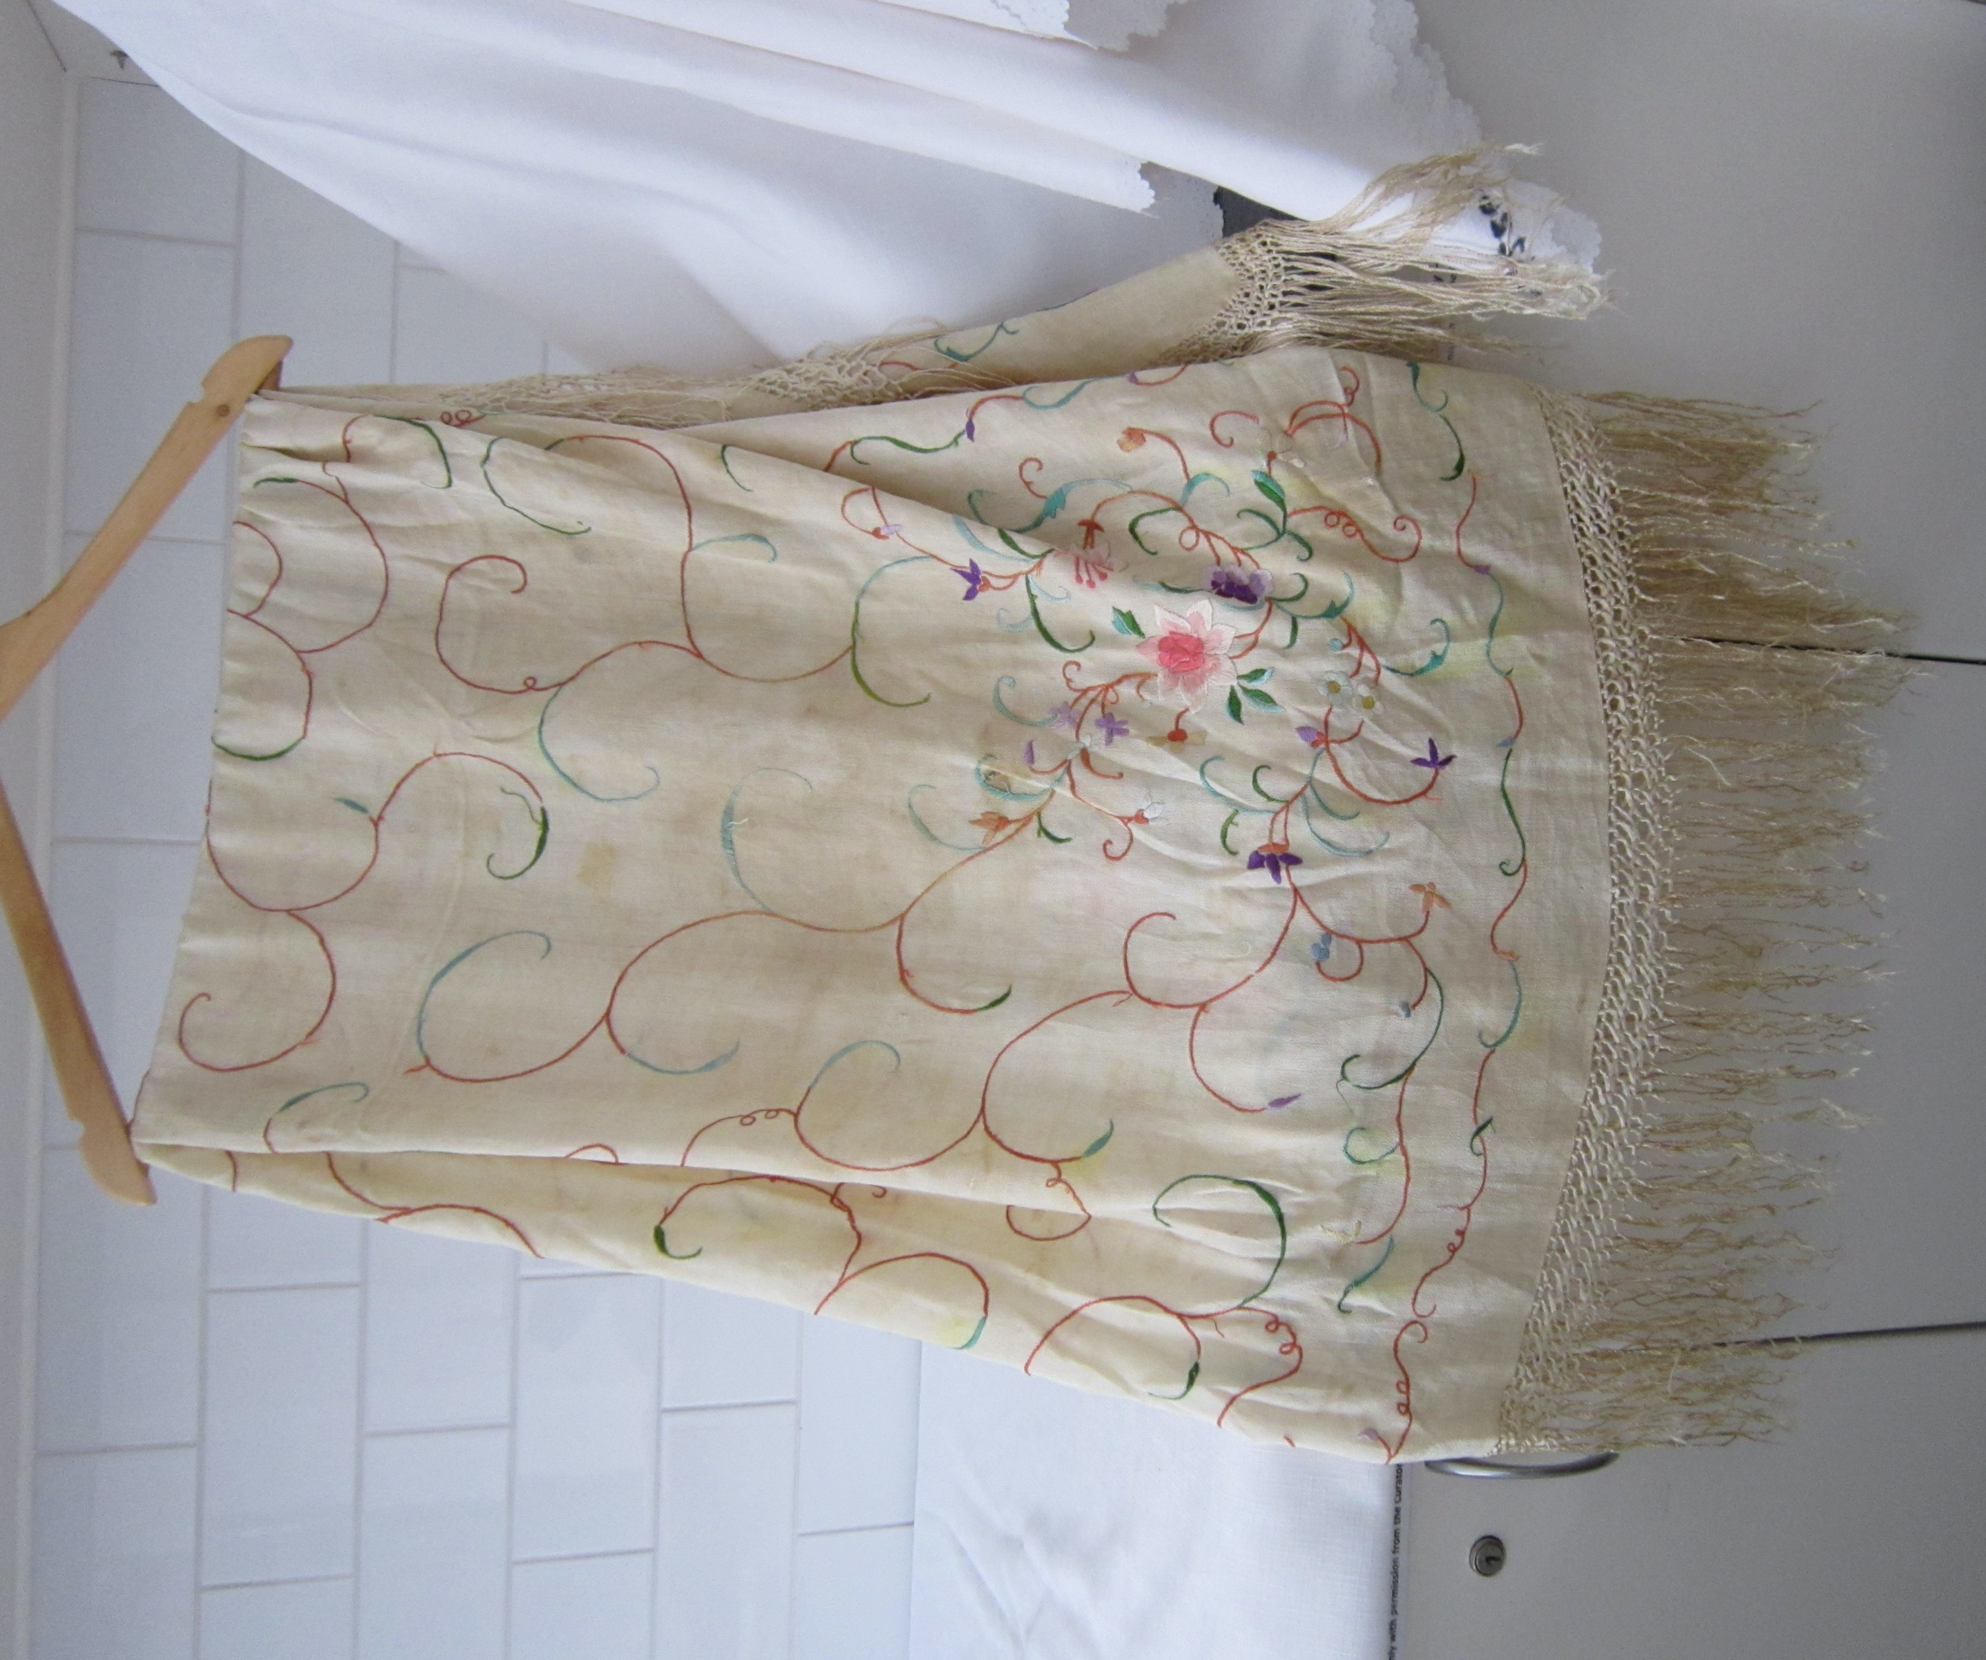
Box 1 includes a photograph of each item

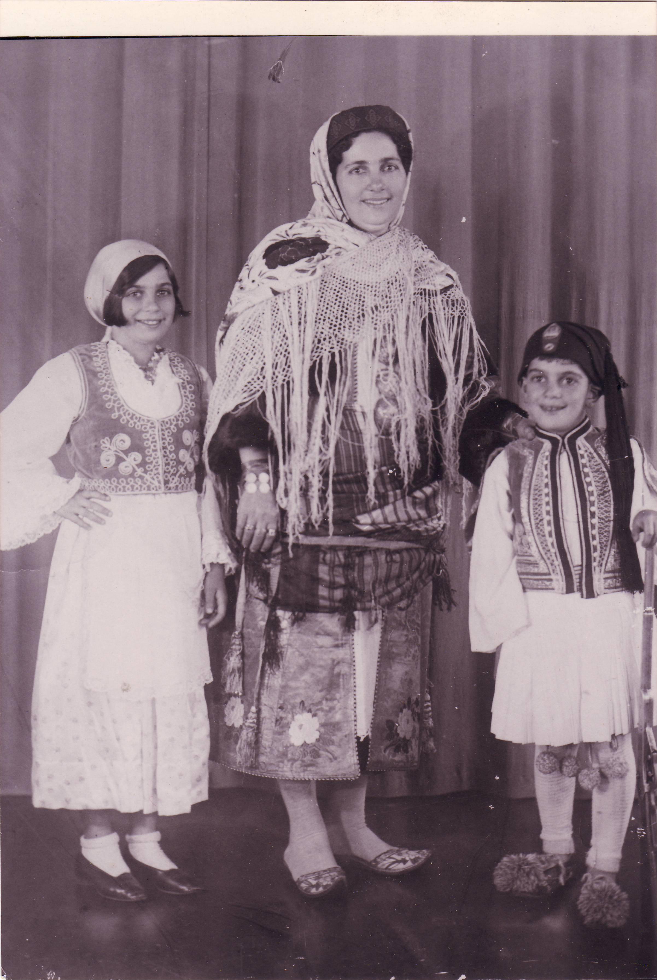
Box 1 includes a photograph of the items being worn.
Circa Early 1930s Melbourne Maria Mangos with two of her children Chrissie & Spiros, wearing Kastellorizian costume. Event unknown.

